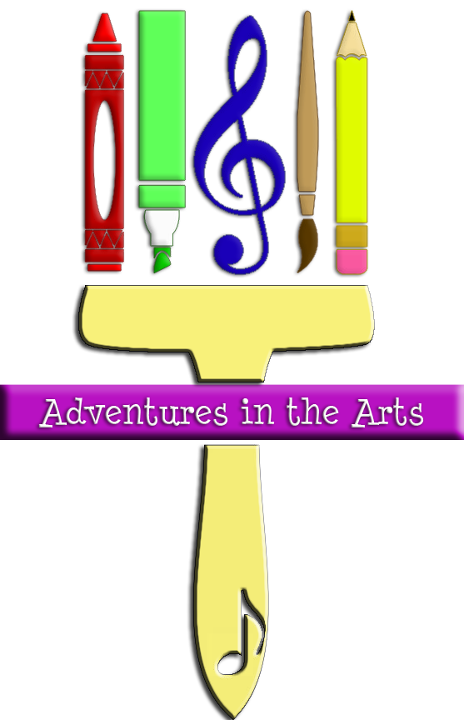REGISTRATION FORM
Adventures in the Arts (AiA) 2022-2023

Complete one form for each child. Please print.

Child’s Name Birth Date
Grade School

Check one: Child will ride the church bus. ____ Child will be dropped off at the church.

Home Address

City Zip

Would you like to receive weekly updates about events at Lighthouse CPC? Yes No

Who will be picking up your child on a regular basis? ________________________________

List anyone else who has permission to pick up your child:

Parent/Guardian Information PLEASE PRINT.

Parent’s Full Name: Mom: Dad:
Work Phone: Mom: Dad:
Cell Phone: Mom: Dad:
Best Email to Use: Mom: Dad:
The best way to reach me with information about AiA is [check one]:
text email phone call
Nearest relative or friend to contact in case of emergency:
Full Name: Relationship:
Their Work / Cell Phone:
AiA is a program offered in a loving, Christian atmosphere and is designed to give children experiences to learn and grow through creative arts—arts and crafts, music and drama. There is a limited number of children we can accept into this program. I understand that my child is expected to be regular in attendance at AiA.

I am to call the church office 386.677.4076 or call/text Suzan Howes 386.795.0085 by noon on Wednesday if my child is going to be absent that day.

Parent’s signature: ___________________________________________________________
Medical Information

pLEASE LIST ANY SPECIAL CONDITIONS, ALLERGIES, AND ANY MEDICATION YOUR CHILD IS PRESENTLY USING ON A REGULAR BASIS. pLEASE INDICATE ANYTHING THAT WE MIGHT NEED TO KNOW REGARDING THE HEALTH AND SAFeTY OF YOUR CHILD.

Please sign below affirming you understand all the information in this form and, if noted above, that you consent for your child to be picked up from school by the Lighthouse Christ Presbyterian Church bus for Adventures in the Arts (AiA) on Wednesdays when AiA is in session.

Parent/Guardian Signature Date

Registrations are not final until payment is received.

Completed registration forms, medical form, signed media release forms,
and payment must be submitted by August 26, 2022.

FOR OFFICE USE ONLY.

Payment date: AMOUNT:

BUS FUND

ChecK # CREDIT CARD CASH Scholarship

RECEIVED BY:

Please keep this page for your future reference.

Adventures in the Arts Registration Form 2022-2023
A ministry of Lighthouse Christ Presbyterian Church
AiA is celebrating our 9th year!

What: Instruction in the arts including music and visual arts. Snack, recreation and fun will be included!
Where: Lighthouse Christ Presbyterian Church, 1035 W. Granada Blvd, Ormond Beach, FL 32174-9169
When: Wednesday afternoons after school dismisses until 4:00 p.m.
We will be following the public school 2022-2023 calendar for early release or regular release days and holidays.
Who: Children, kindergarten-grade 5, whose families want them to participate in a music and arts program.
Cost: $30 per semester ($25 for second child, $20 for 3rd child). Scholarships available.
Transportation: provided from Tomoka, Pinetrail and Pathways Elementary Schools by the church or the parent.
Children must be picked up from Lighthouse CPC promptly at 4:00 p.m.

Completed registration forms, medical and signed media release forms, and payment must be in our hands or postmarked no later than August 26, 2022.

What you should expect from us: Your child will be safe and cared for while having a fun time learning about the arts, relating to God and others during Adventures in the Arts. AiA is staffed with qualified leaders and committed volunteers, with a level one background check.

What we expect from you: Adventures in the Arts is based on a curriculum that builds upon itself each week, so we ask that children attend for the entire time to really gain the total experience AiA provides. If your child is going to be absent, you must let the office know before Wednesday at noon.
Good behavior is expected during AiA events and activities. When there is misbehavior, the child will be warned and a note sent home to parents. If the problem continues, there will be a discussion with child and parent, and then a possible 2 week suspension from AiA.

Questions? Contact Lighthouse CPC at 386.677.4076, or Suzan Howes, Adventures in the Arts Coordinator at 386.795.0085 or AiA@lighthousepresob.org.

Important dates

First Semester
Wednesday, Sept 7 - AiA begins
Nov 23 - NO AiA - Thanksgiving Break
Wednesday, Dec 14 last day of AiA

Second Semester 2023
Wednesday, Jan 4 - First day of AiA
March 15 - NO AiA – Spring Break
Wednesday, May 17 - last day of AiA till fall, 2023

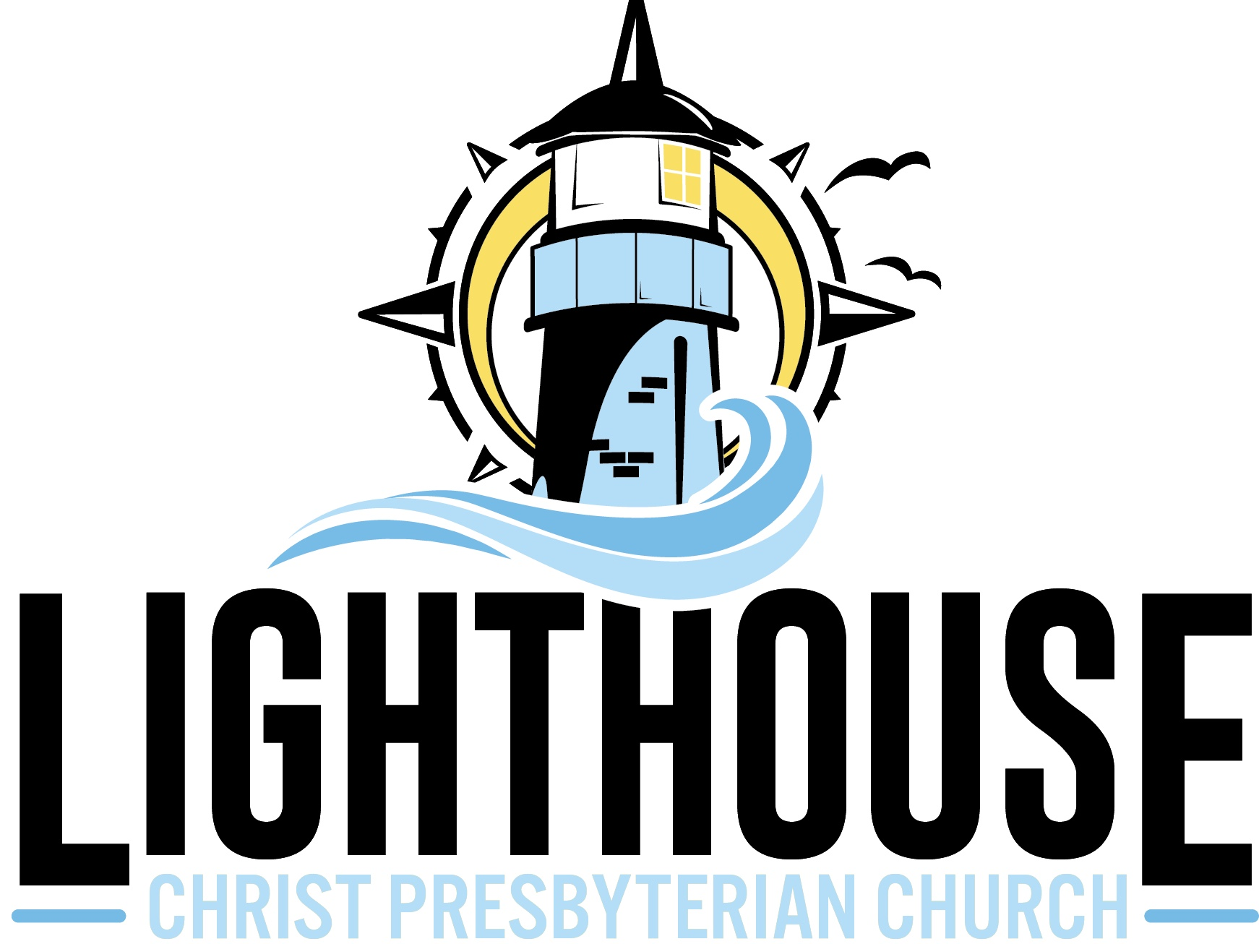

A Christ-centered family called to witness, serve, and love the world
Adventures in the Arts Student Media Consent and Release Form
Please print. One form per child.
Throughout the school year, students may be highlighted in efforts to promote Lighthouse CPC activities and achievements. For example, students may appear in our weekly Email Beacon Blast, in our Sunday announcements, or on our website, lighthouseormond.com, and other types of media.
I, as the parent or guardian of _______________________________________________,
hereby give prohibit Lighthouse CPC and its employees, representatives, and authorized media organizations permission to print, photograph, and record my child for use in audio, video, film, or any other electronic, digital and printed media.
a. This is with the understanding that neither Lighthouse CPC nor its representatives will reproduce said photograph, interview, or likeness for any commercial value or receive monetary gain for use of any reproduction/broadcast of said photograph or likeness. I am also fully aware that I will not receive monetary compensation for my child’s participation.
b. I further release and relieve Lighthouse CPC, its governing board, employees, and other representatives from any liabilities, known or unknown, arising out of the use of this material.
I certify that I have read the Media Consent and Release Liability statement and fully understand its terms and conditions.
**Please understand that failure to return this release form within ten (10) school days from the date of distribution will constitute approval of the above requests. **

Name of child Grade

Address

City, State, Zip

Signature of parent or guardian

Date Phone Number

Reverend Dr. Michael Foley, Interim Pastor

Suzan Howes, Adventures in the Arts Coordinator

