Sermon Notes

Pastoral Staff

Rev. Dr. R. Michael Foley…….Interim Pastor……..PastorMike@lighthousepresob.org
Susan Pitard Acree…..Interim Director of Music….Music@lighthousepresob.org
Micah Remington……Director of Student Ministry…..Micah@Lighthousepresob.org
Linda Bertolet…..Parish Nurse/Congregational Care….Linda@Lighthousepresob.org

Elders Deacons
Mike Abate Pat Kelly Katie Coleman Mary Schudel
Ron Belton Lorraine Miklos Lynn D’Louhy Marcy Tyner
Matt Coleman Cheryl Ogle Georgia Harrington Michele Wallens
Lew Darr Wayde Sumerix Pam Kelly Paula Warnicke
Bonda Garrison Phil Sweet Denice Schilsky Herb Wilkinson
Ed Haase Bill Wagner Barb Willett
Susan Kaznoski Tony Zaffuto

Flowers in the Sanctuary Today were Given by

Gloria Lee
In celebration of her sister, Rose’s, birthday

Ed and Judy Haase
In celebration of their 61st anniversary

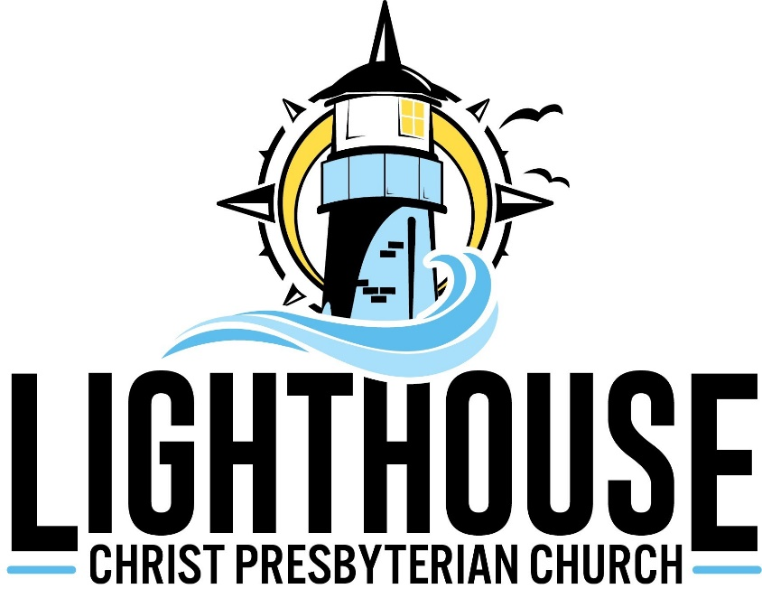
A Christ-centered family called to witness, serve and love the world

1035 West Granada Boulevard
Ormond Beach, Florida 32174-9169
Telephone: 386.677.4076
Website: Lighthousepresob.org

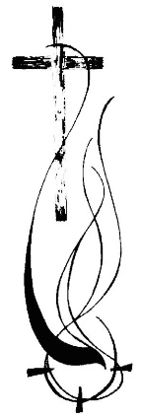
The chancel wall art in black walnut carved by local sculptors Paul Baliker and Paul Greene incorporates the tradition of the cross with a contemporary expression reflecting the Power and Presence of God. The symbol, as rendered, represents “the Spirit of God”-active and alive which moves all people to love and respond. Whatever the worshipper visualizes-the dove, the Trinity, the nimbus, the crown of thorns, the rushing wind and flames of Pentecost, a wave, the IXOYC, the subtle Chi Rho-the Holy Spirit flows from the imprint of the cross with great power and presence and peace.

Celebration of the Lord’s Day

January 16, 2022 10:45 a.m.

Welcome and Announcements

Prelude “Joyful, Joyful We Adore You” arr. Lorie Line
Paige Dashner Long, Organ

Call To Worship
Leader: The light shines in the darkness,
People: and the darkness did not overcome it.
Leader: Jesus Christ is the light of the world.
People: Shine in our lives, Lord Jesus Christ.
Leader: Let us worship God.

Hymn “When Morning Gilds the Skies” (Green #215, v. 1, 2)

Call to Confession

Unison Prayer of Confession
God our Savior, we confess that we fail to live in your light. Christ has come into the world, and yet we do not know him. He has called us to be his own, and yet we do not accept him. Forgive us, God of grace. Shape us by your Word of truth, seal us with your Holy Spirit, and let us live to show your glory; through Jesus Christ our Lord.

Words of Assurance

Anthem “The Master Has Come” arr. Joseph M. Martin Sanctuary Choir

Prayers for the People and the Lord’s Prayer
Our Father,
who art in heaven,
hallowed be thy name;
thy kingdom come;
thy will be done
on earth as it is in heaven.
Give us this day our daily bread;
and forgive us our sins
as we forgive those who have sinned against us;
and lead us not into temptation,
but deliver us from evil.
For thine is the Kingdom and the power and the glory forever.
Amen.

Choral Response “Hear Our Prayer, O Lord” George Whelpton

Scripture John 1:1-14

Sermon “Life Comes from Light” Rev. Dr. Michael Foley

Call to Offering
This time of giving is a sacred symbol of our intent to live as God intends. The offerings you give empower ministry within our congregation and allow us to respond to the needs of our community and world. Give generously from the gifts you have been given. There are several ways to give online or you may leave your offering in the baskets as you leave worship today.

Offertory “Duo V in G Major” Francoise Devienne
Paige Dashner Long, Flute; Susan Pitard Acree, Violin

Prayer of Dedication

Hymn “We’ve a Story to Tell to the Nations” (Green #446, v. 1, 2)
Benediction

Postlude “Te Deum” Marc Antoine Charpentier

